Canadian College of Performing Arts
Visual Story for visitors at a Relaxed Performance



The show is being performed at the Canadian College of Performing Arts.

This is a photo of the College from Elgin Road.

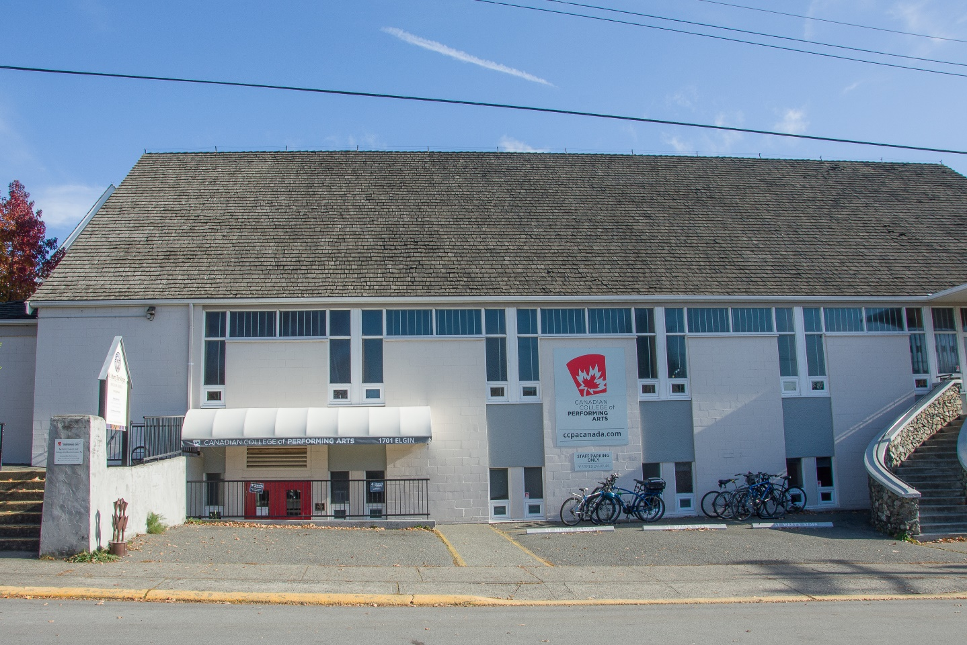

To get to the theatre, you can go up a ramp or a set of stairs.

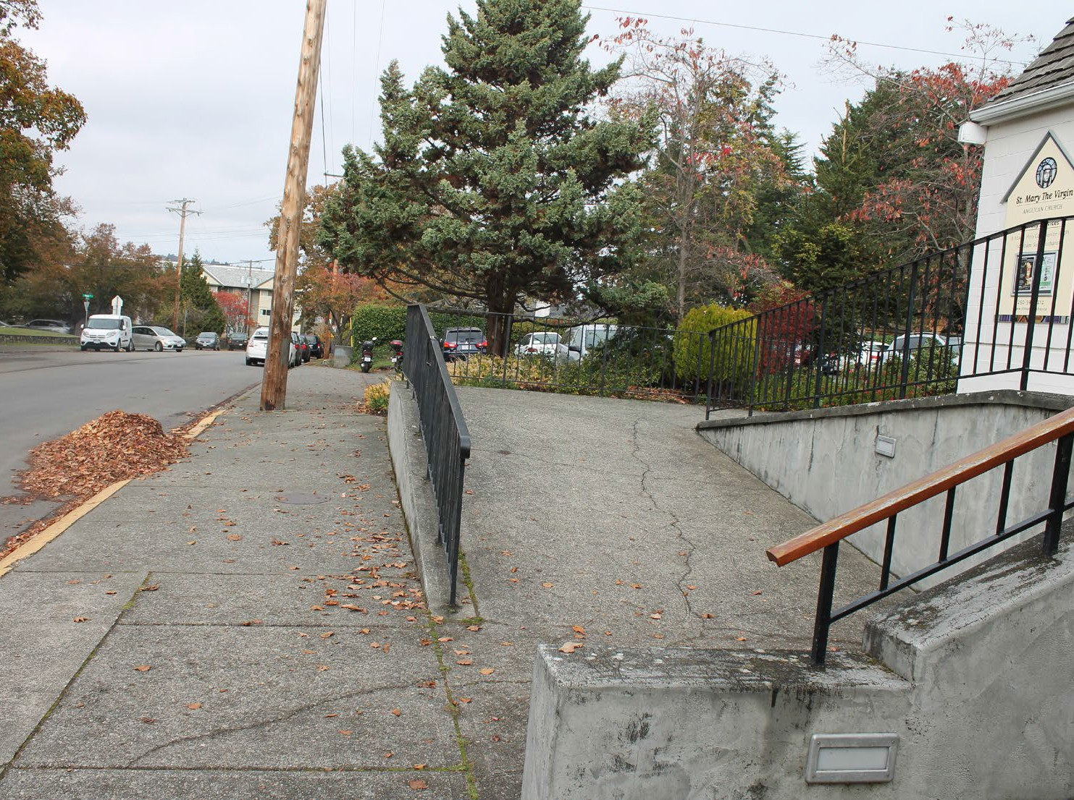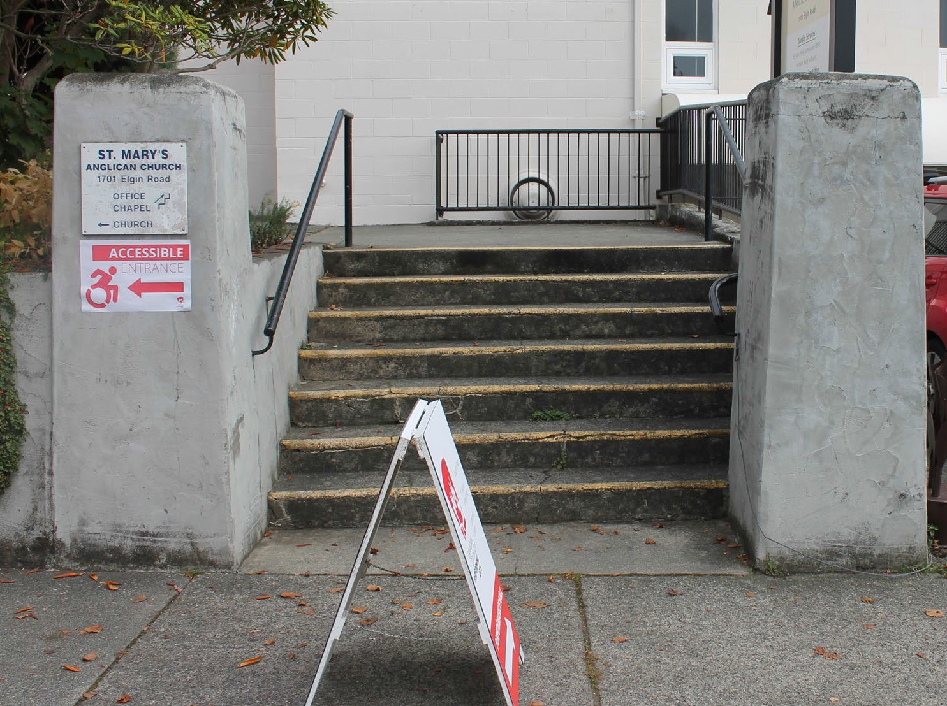

The path from the ramp to the theatre takes you through a small garden.

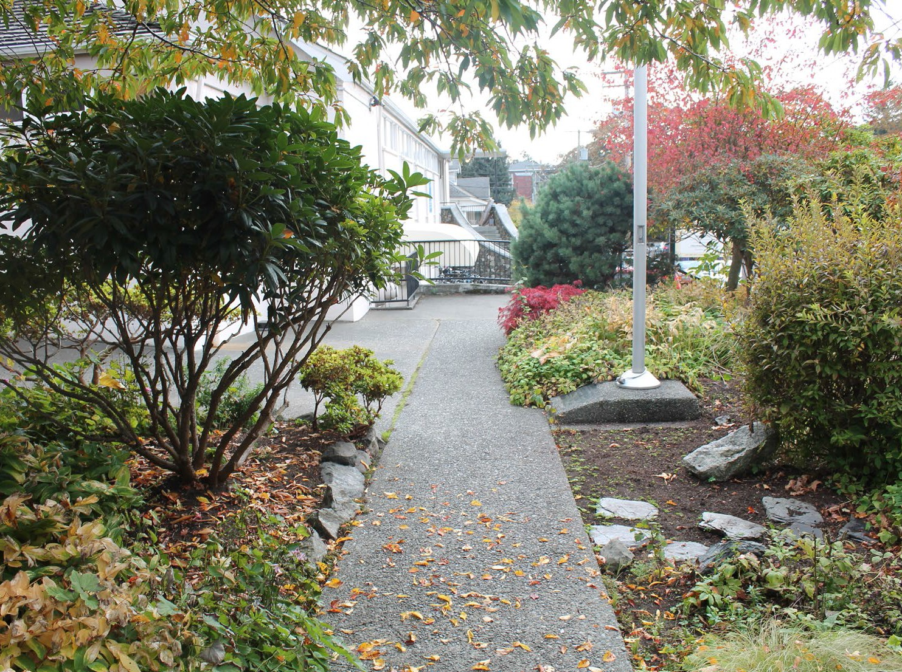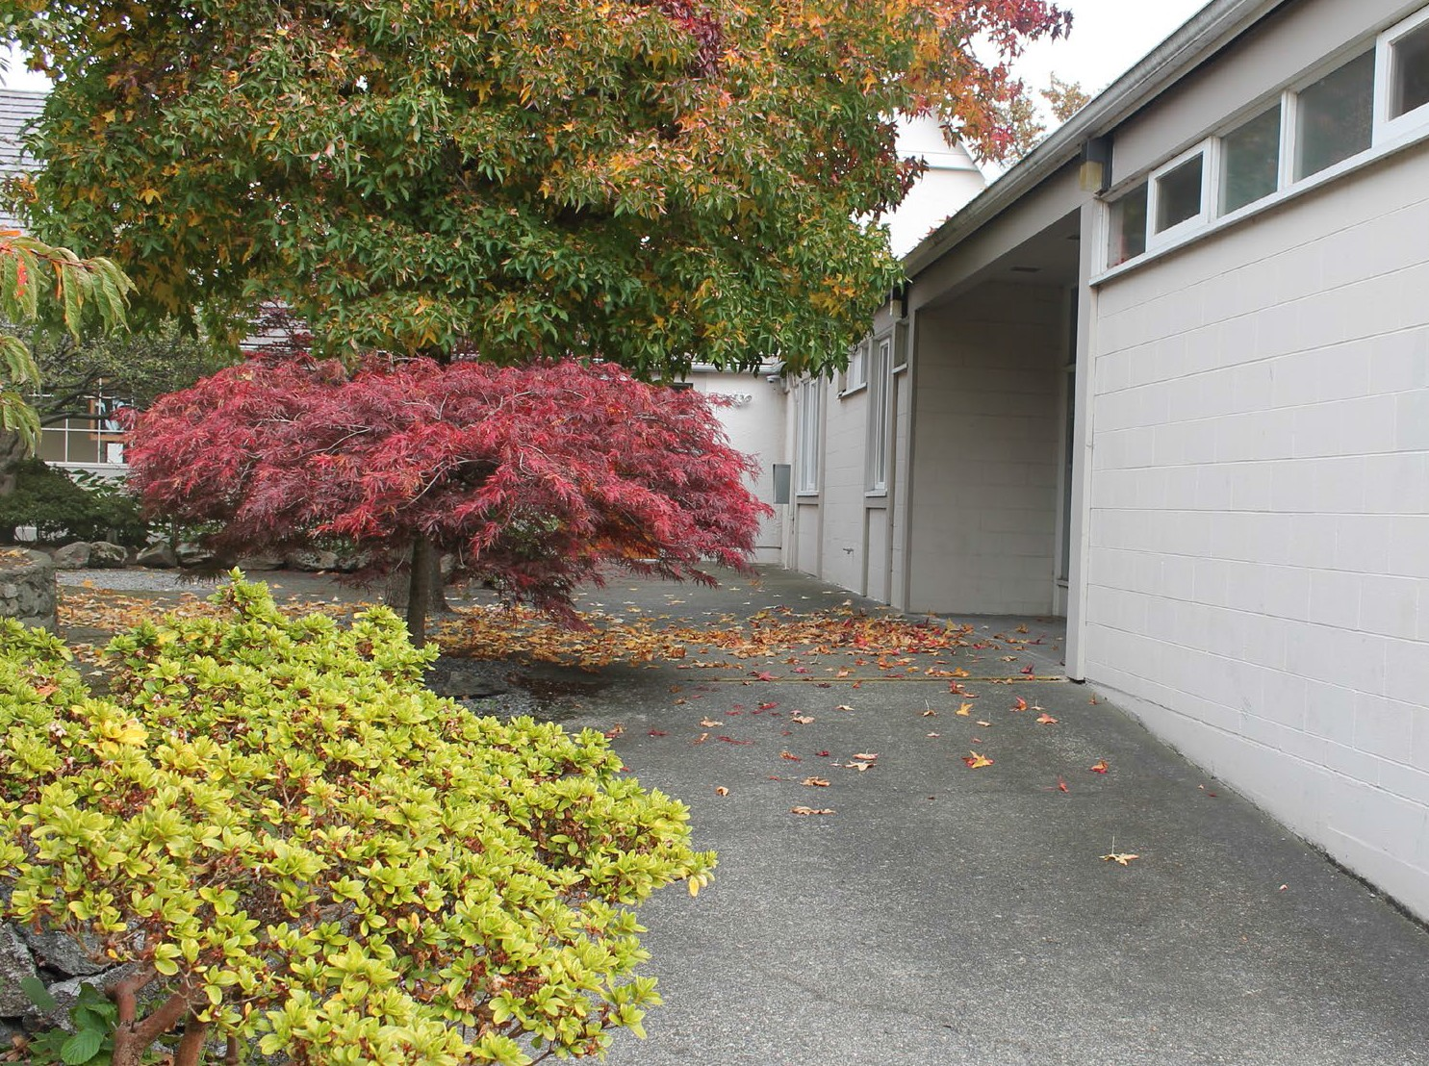

These are the doors to the theatre.

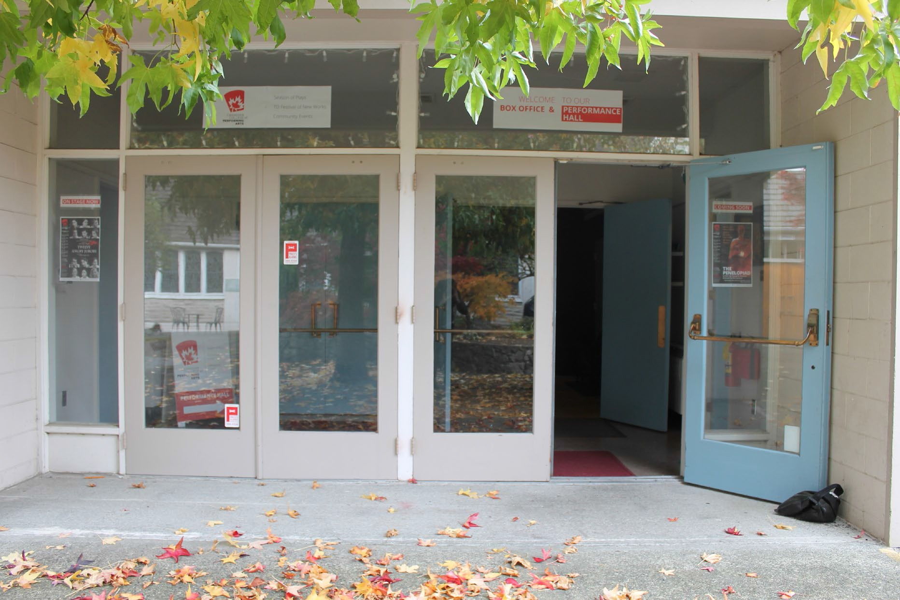

Inside, you’ll be greeted by someone at our box office. You can check in here if you’ve already bought a ticket.

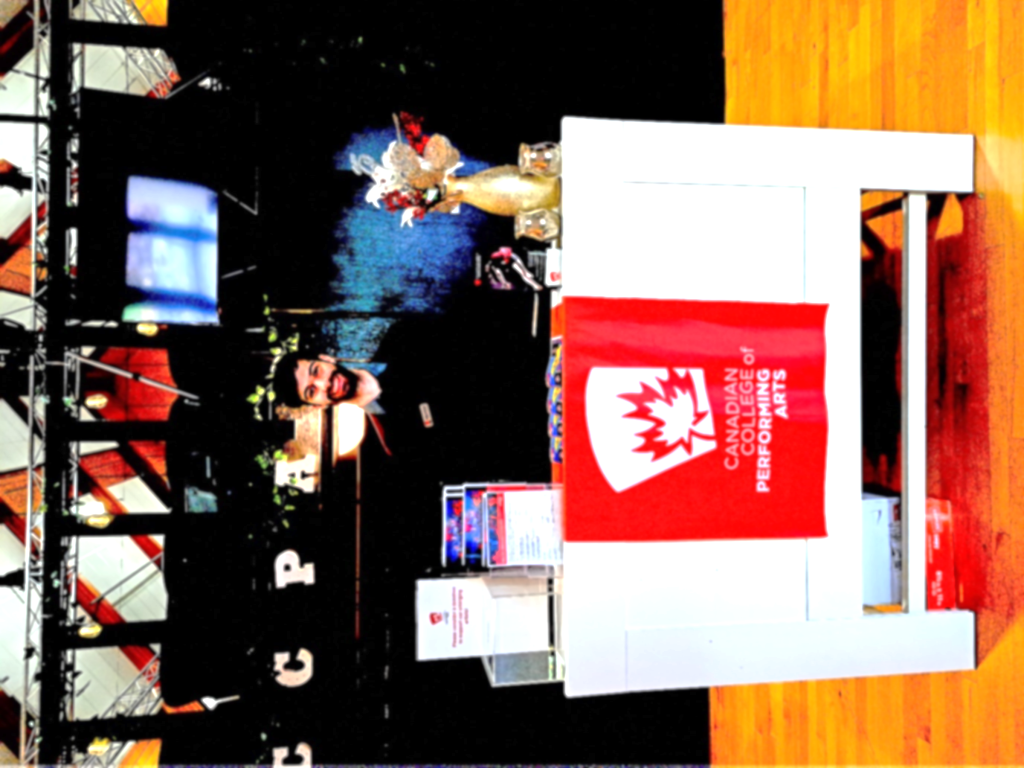

If you require a special accommodation, please contact us in advance at 250 595 9970 extension 104.

These are the doors into the Performance Hall.

You can pick up a program from a volunteer outside
the doors.
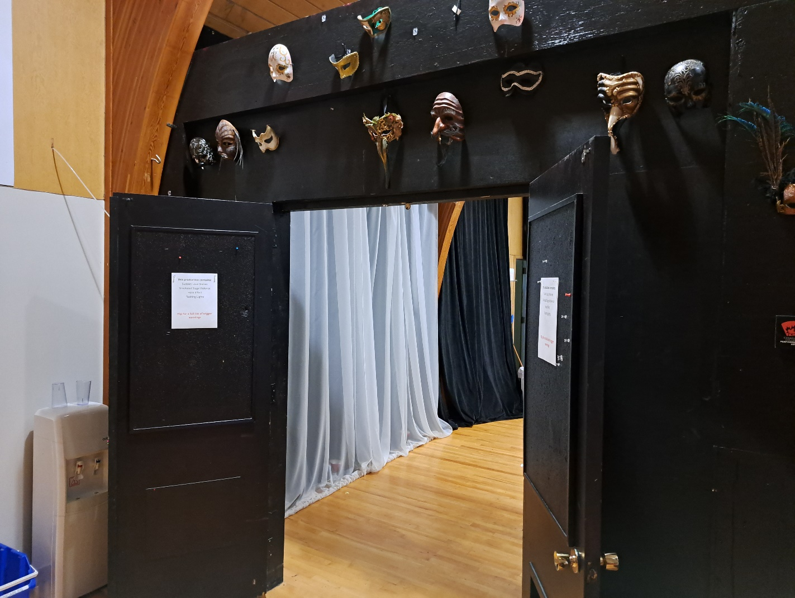

Ushers will be here to help you if you have a question.
Here is a picture of the shirt the ushers will be wearing. There may also be volunteers wearing nametags.

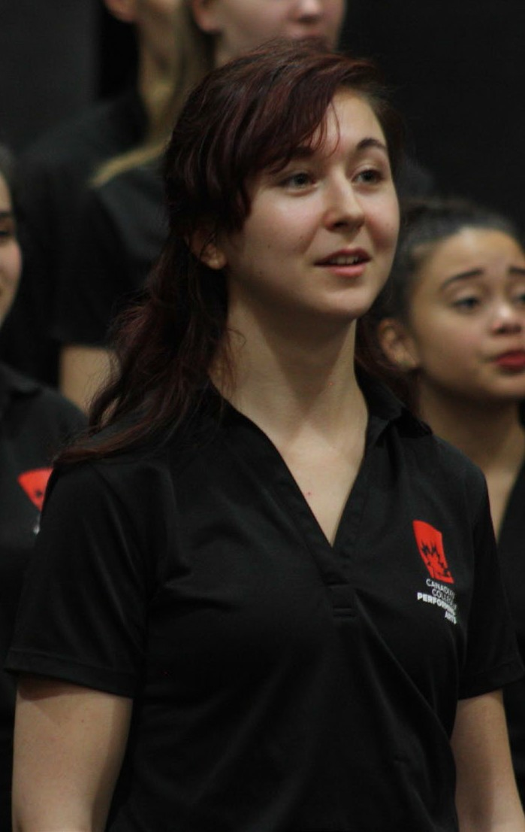

This set of doors leads to the hallway where the washrooms are.

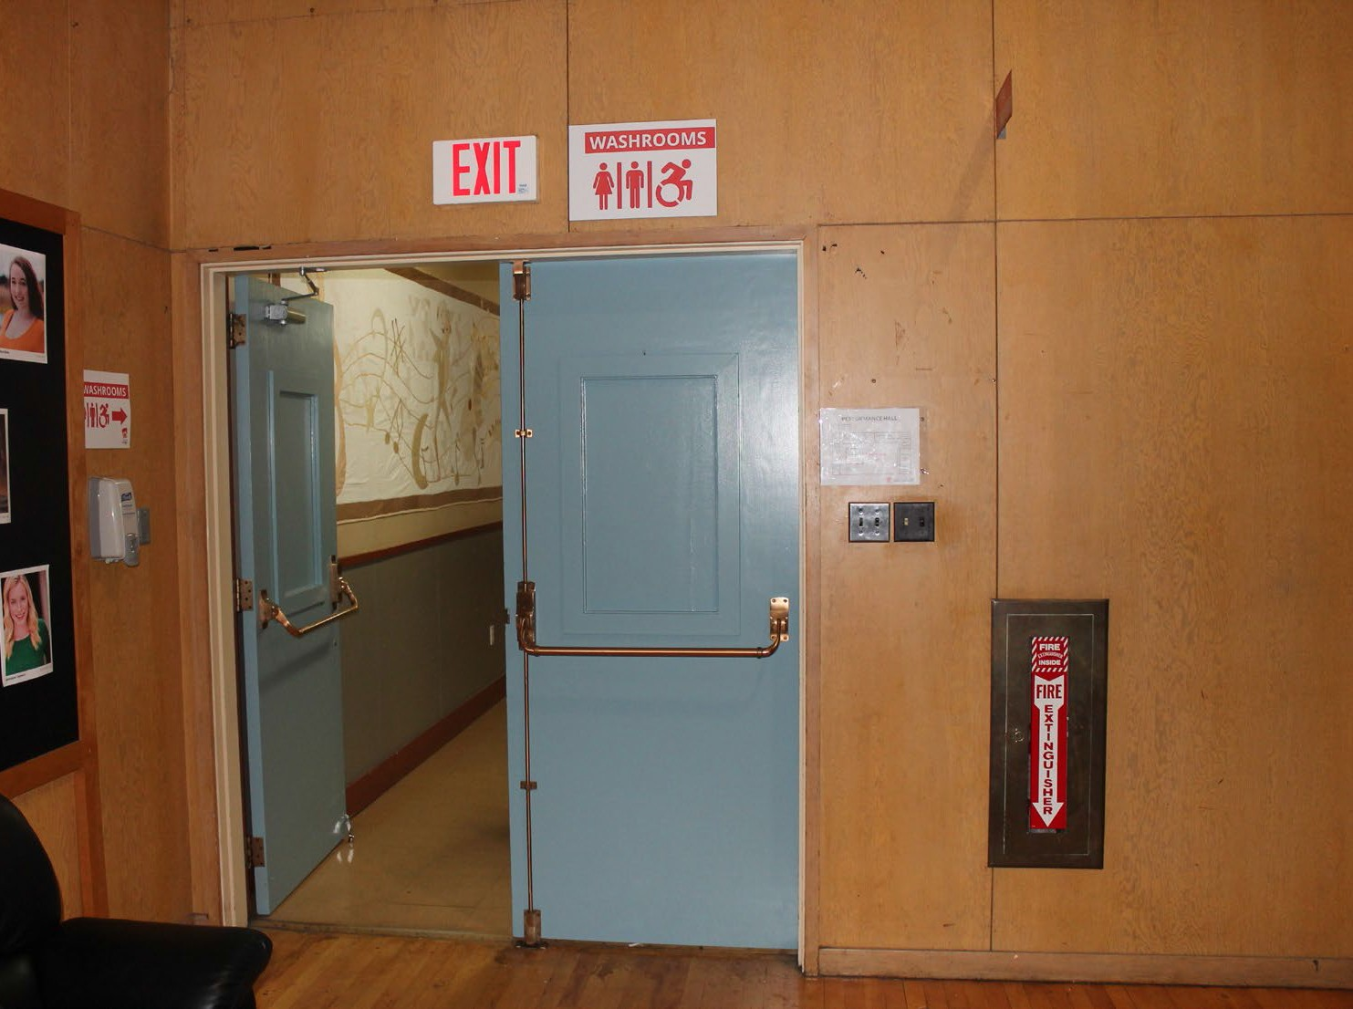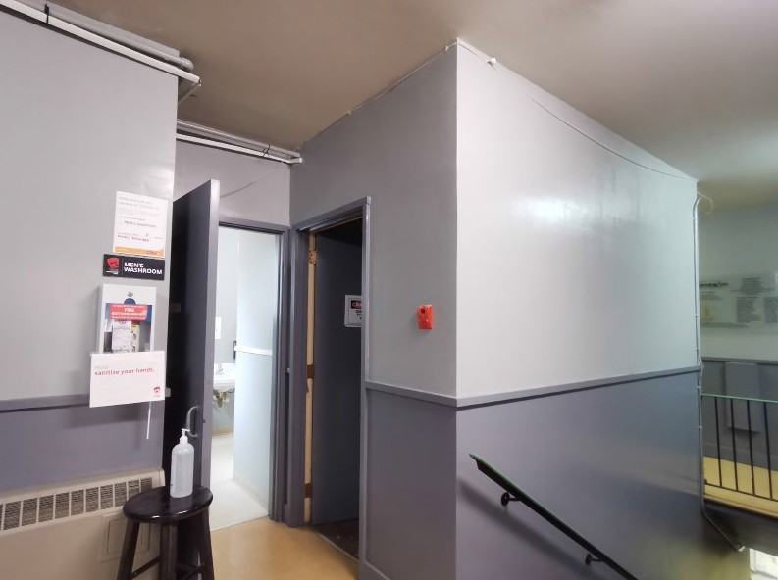

The single door at the end of the hallway is where the accessible washroom is.

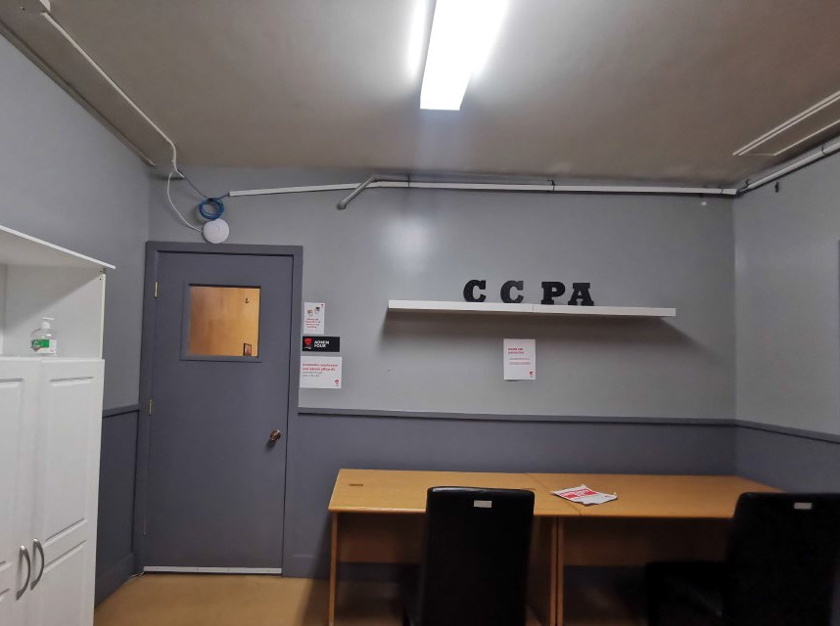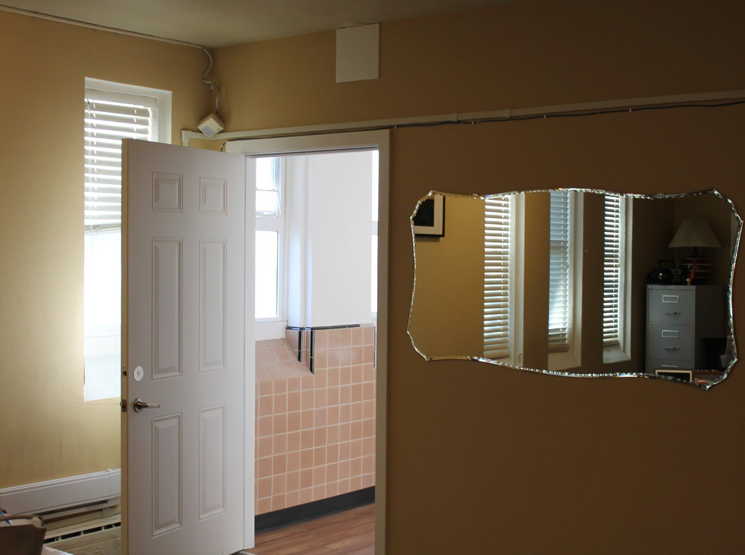

We have a quiet calm space available. You can leave the Performance Hall any time during the show to relax. It is near the entrance into the building.

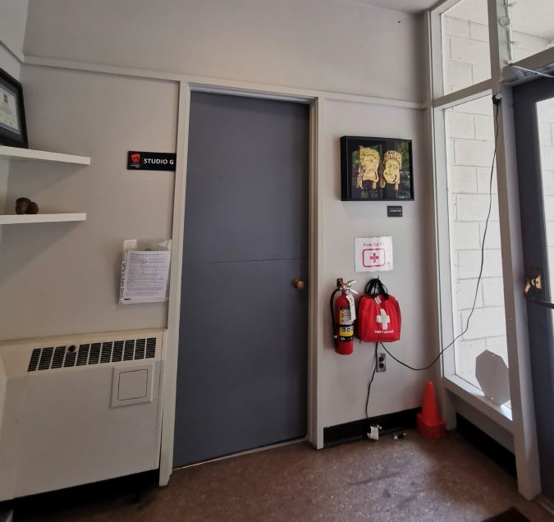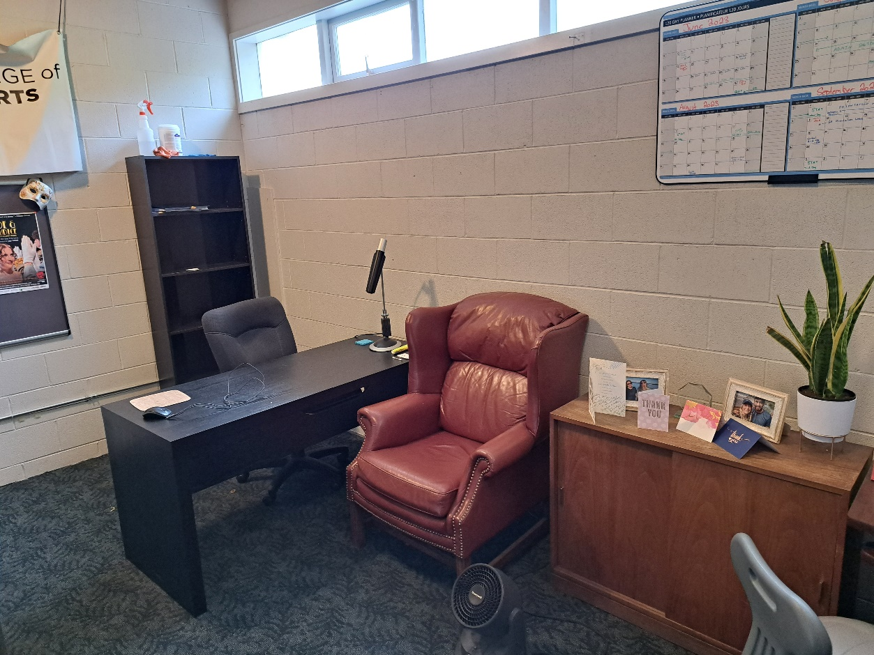

These are your seats in the Performance Hall. You can stand up and move around any time during the performance. The house lights will stay on so you can see.

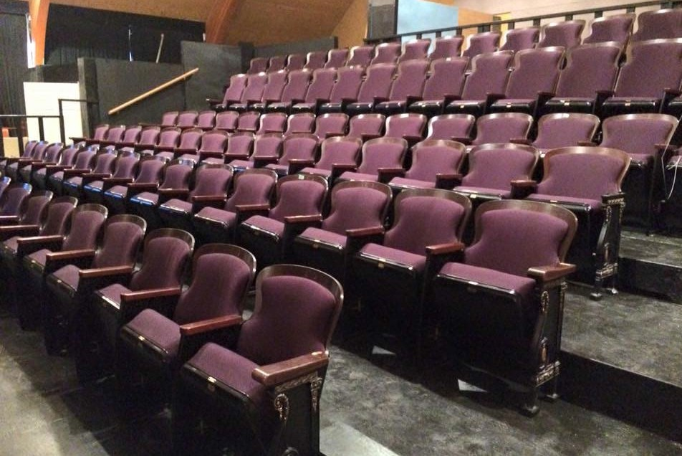

Special information about Antigone: 方

This production has more seats on each side of the stage. You are welcome to sit here, but it may make the performance more intense. These seats are also not recommended if you are sensitive to light.
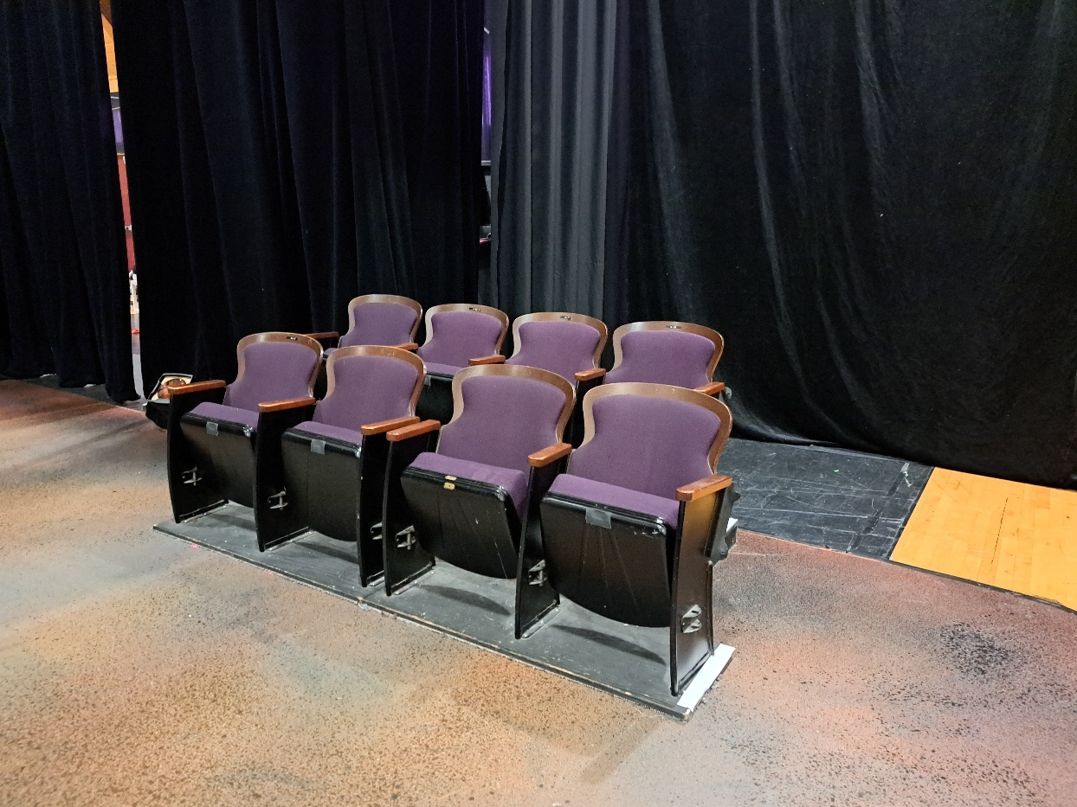

Story

In some future world, not unlike ours, a family led by Police Chief Kreon is caught in the conflict. A dictatorship has created a society of oppression which sentences Kreon’s wife Eunice to a re-education centre. Her son Neikes attempts to free her, only to discover the terrible conditions at the centre. Radicalized, Neikes leads a protest of the ruling forces, while his brother Teo attempts to stop it, both losing their lives in the ensuing clash. Their sisters, Antigone and Ismene debate whether to go to the protest, with Antigone ultimately deciding to go to reclaim and honour her brother’s body.

Content Warnings

ANTIGONE: 方 contains water-based haze and sounds of gunshots, as well as depictions of violence, parental violence, state oppression, and death.

Additional Trigger Warnings

Puppets, Protests, Poison gas, Police violence, Loud megaphone sounds

There may be other intense or frightening moments in the play. If you are worried about anything in particular, please call us at 250 595 9970 ext 104 or talk to a staff member before the show.

