**Canadian College of Performing Arts**

Visual Story for visitors at a Relaxed Performance



The show is being performed at the Canadian College of Performing Arts.

This is a photo of the College from Elgin Road.

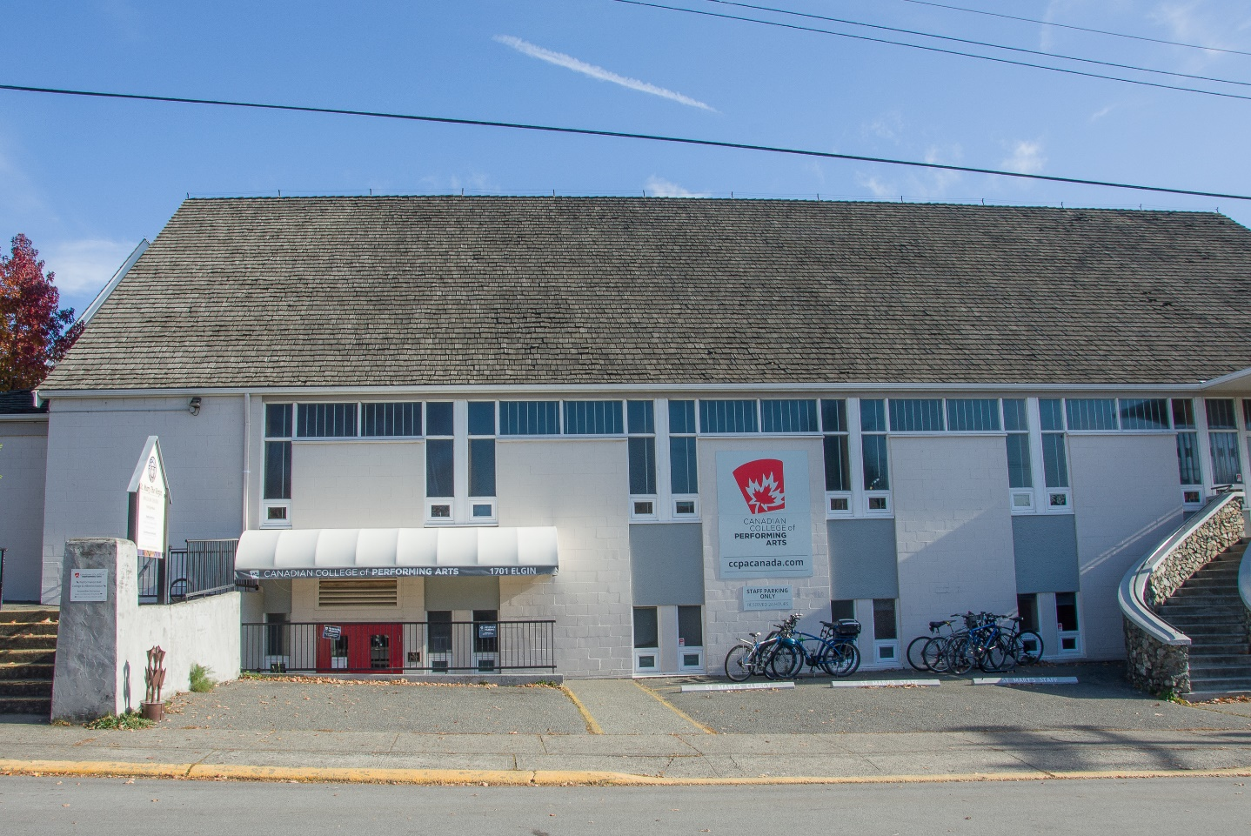

To get to the theatre, you can go up a ramp or a set of stairs.

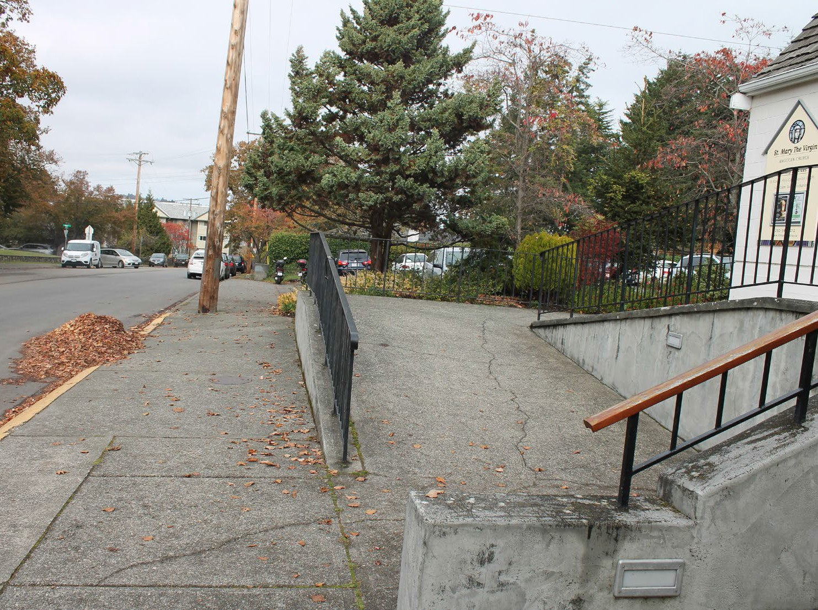 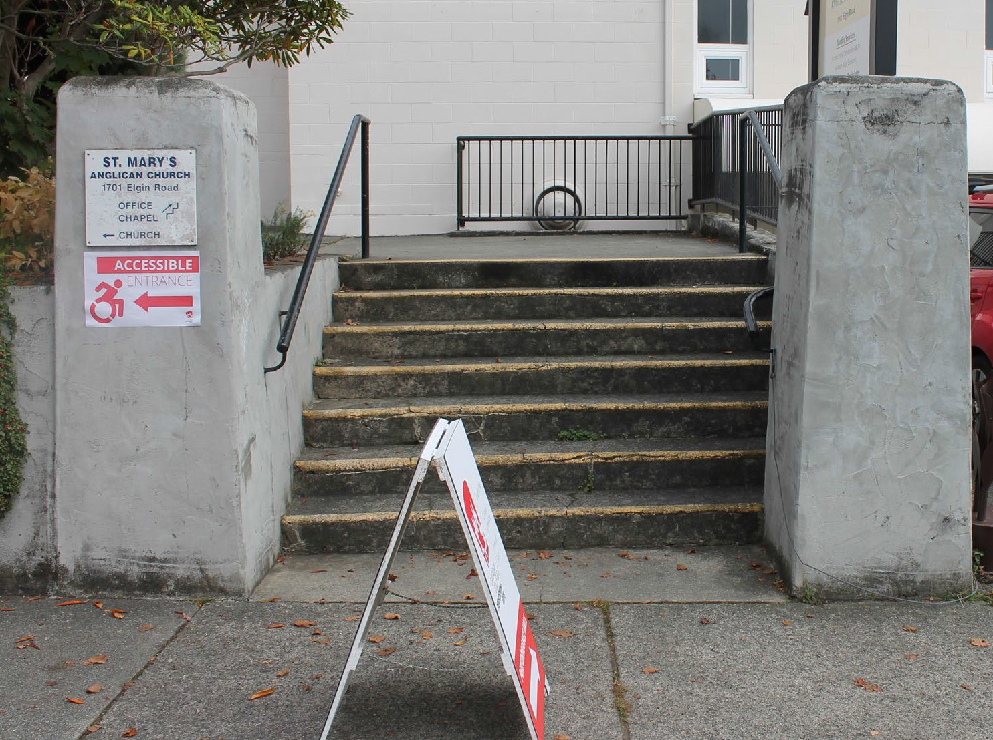

The path from the ramp to the theatre takes you through a small garden.

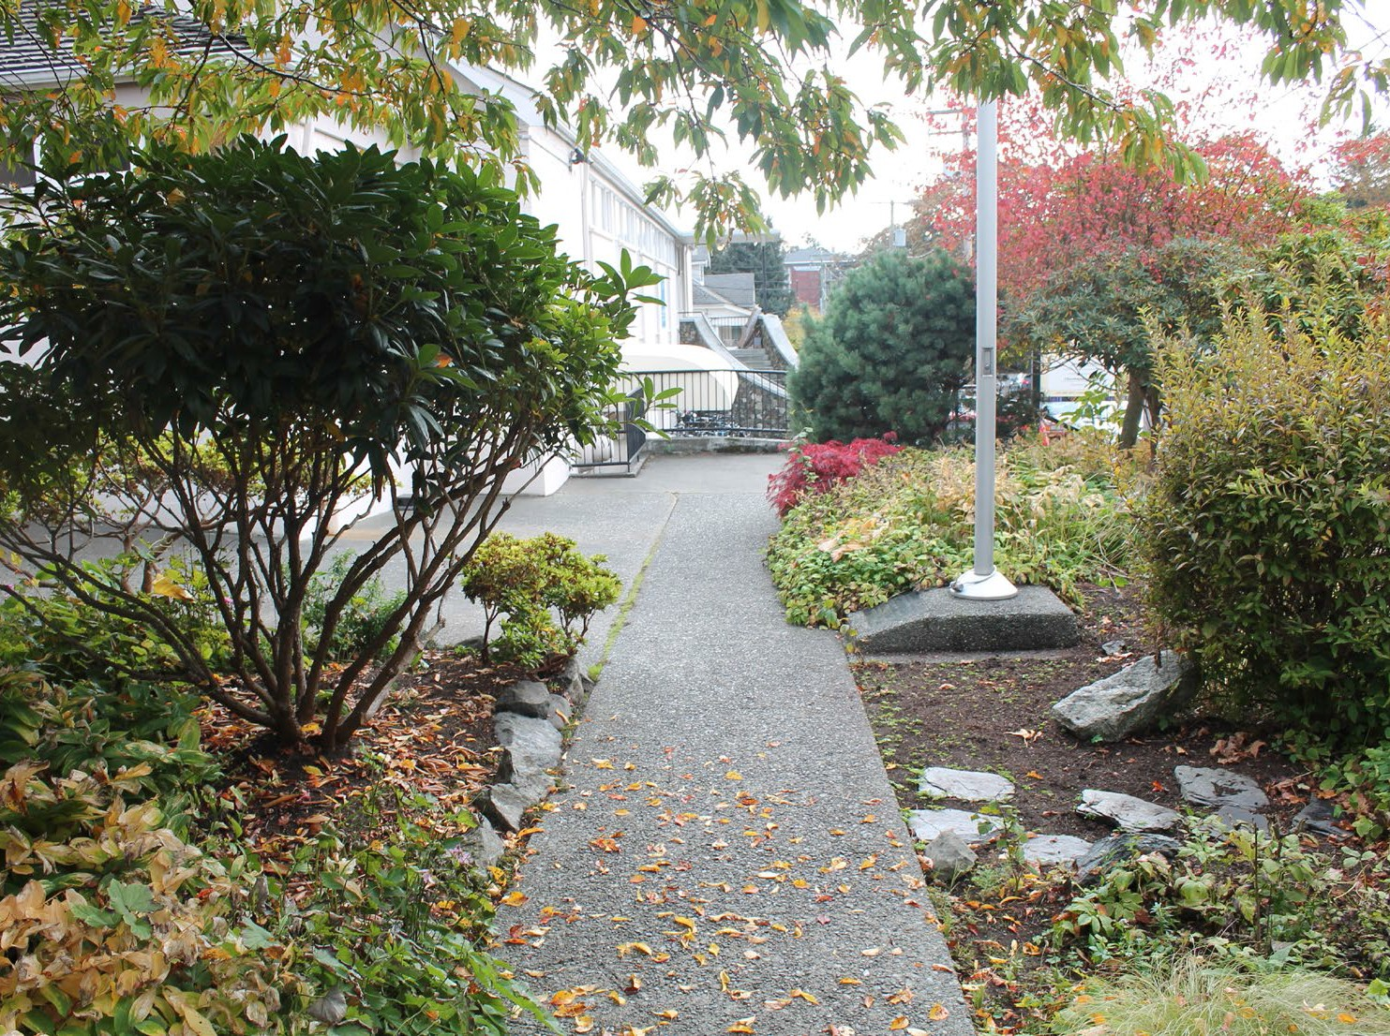 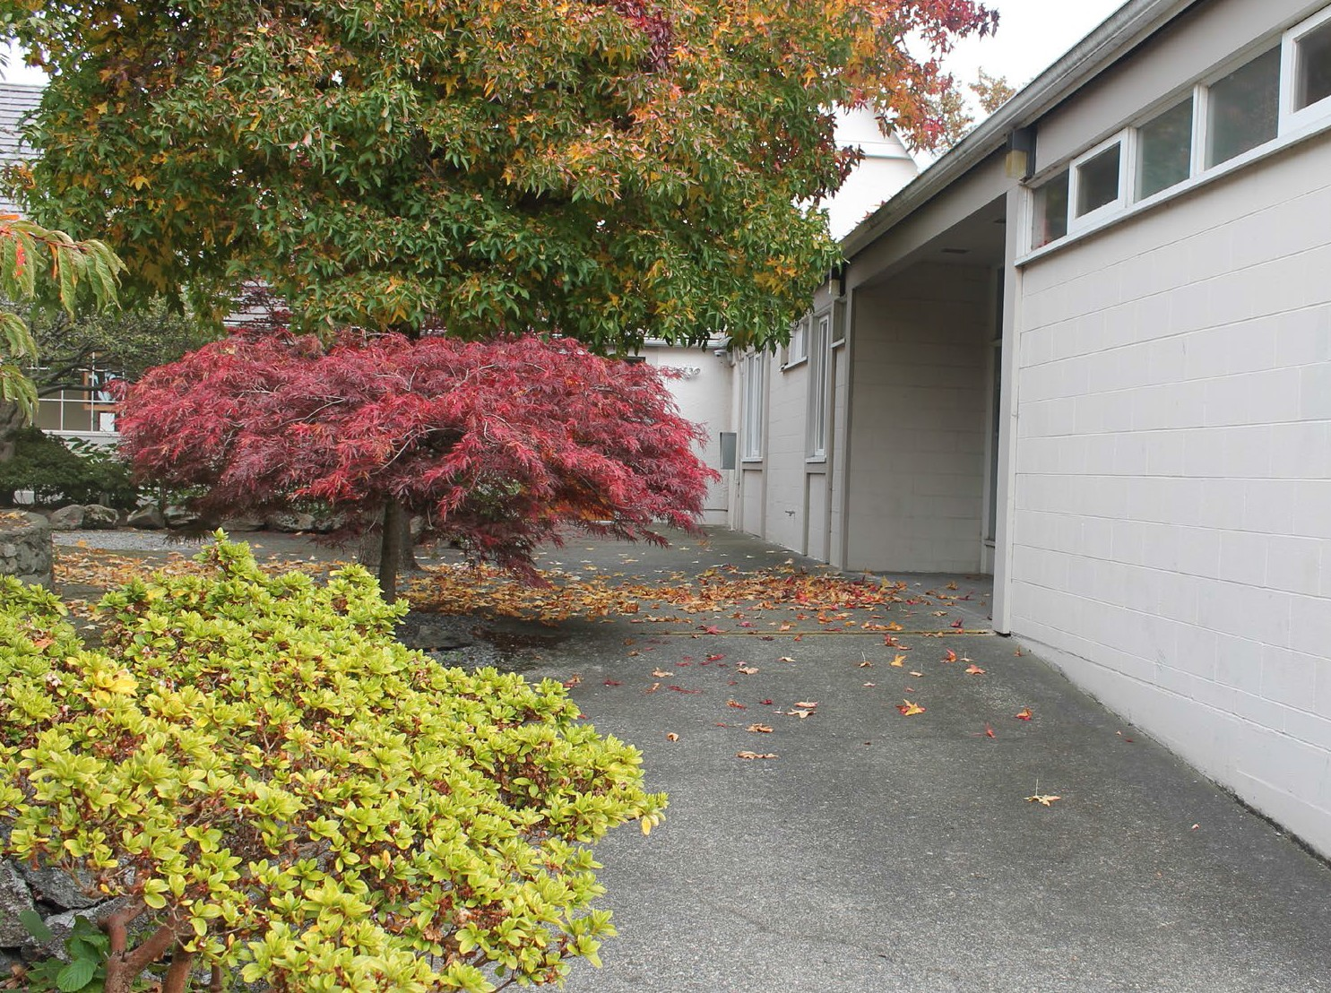

These are the doors to the theatre.

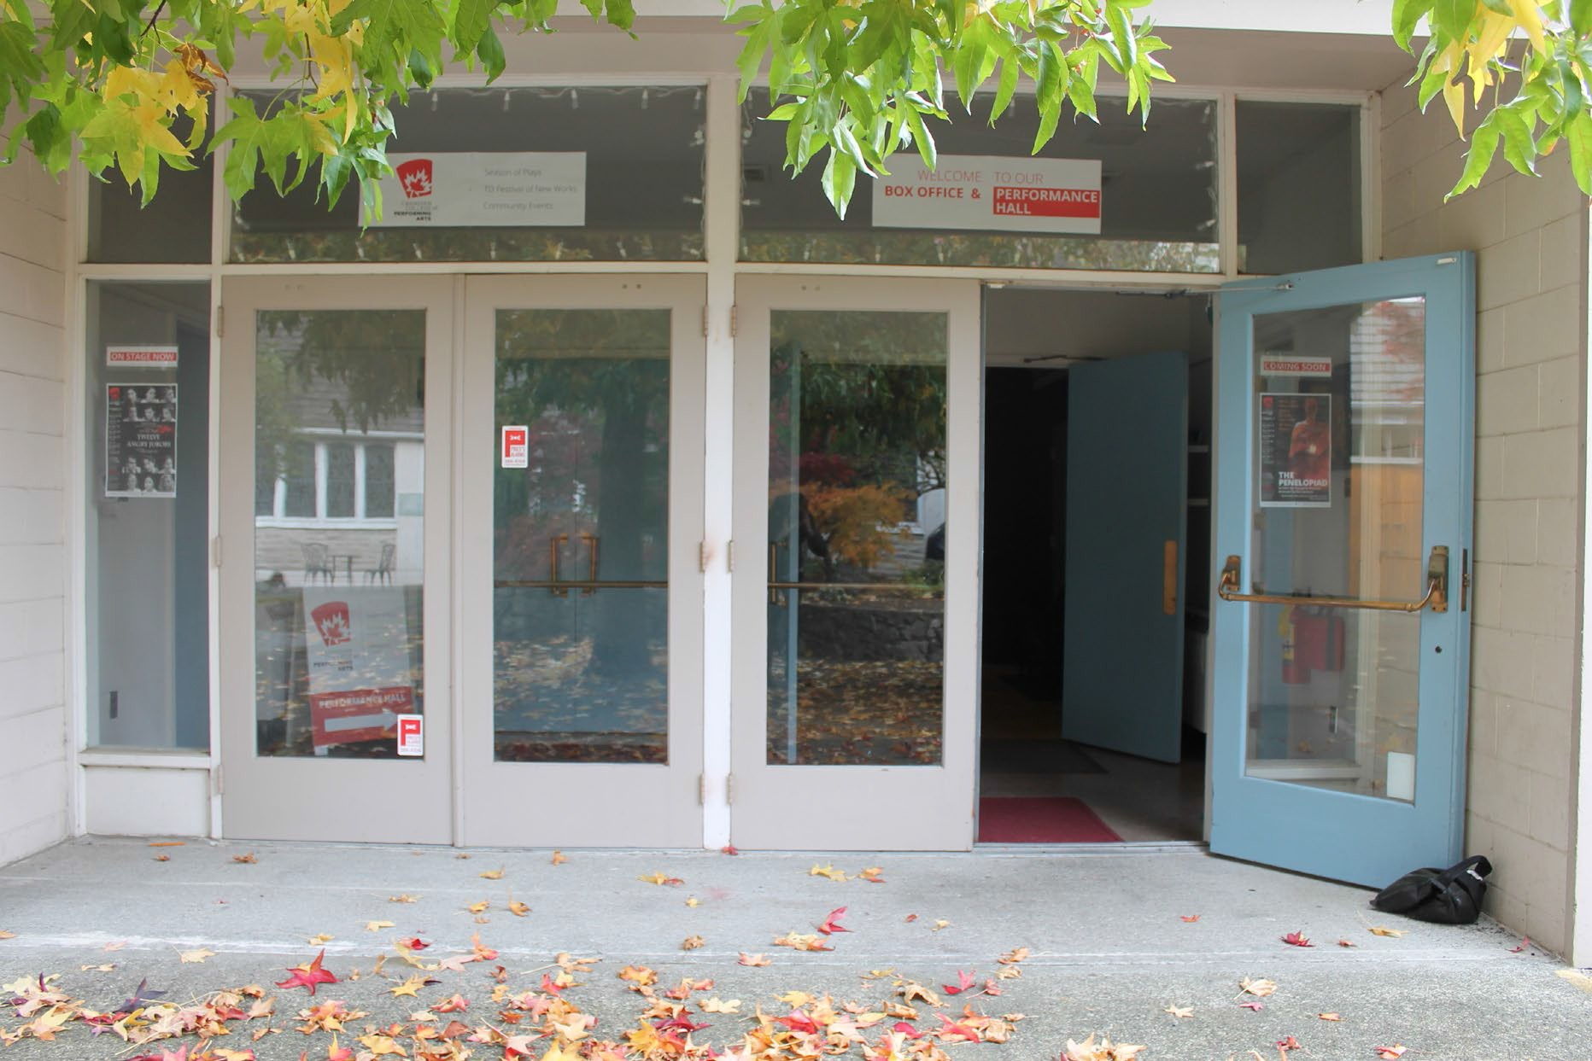

Inside, you’ll be greeted by someone at our box office. You can check in here if you’ve already bought a ticket.

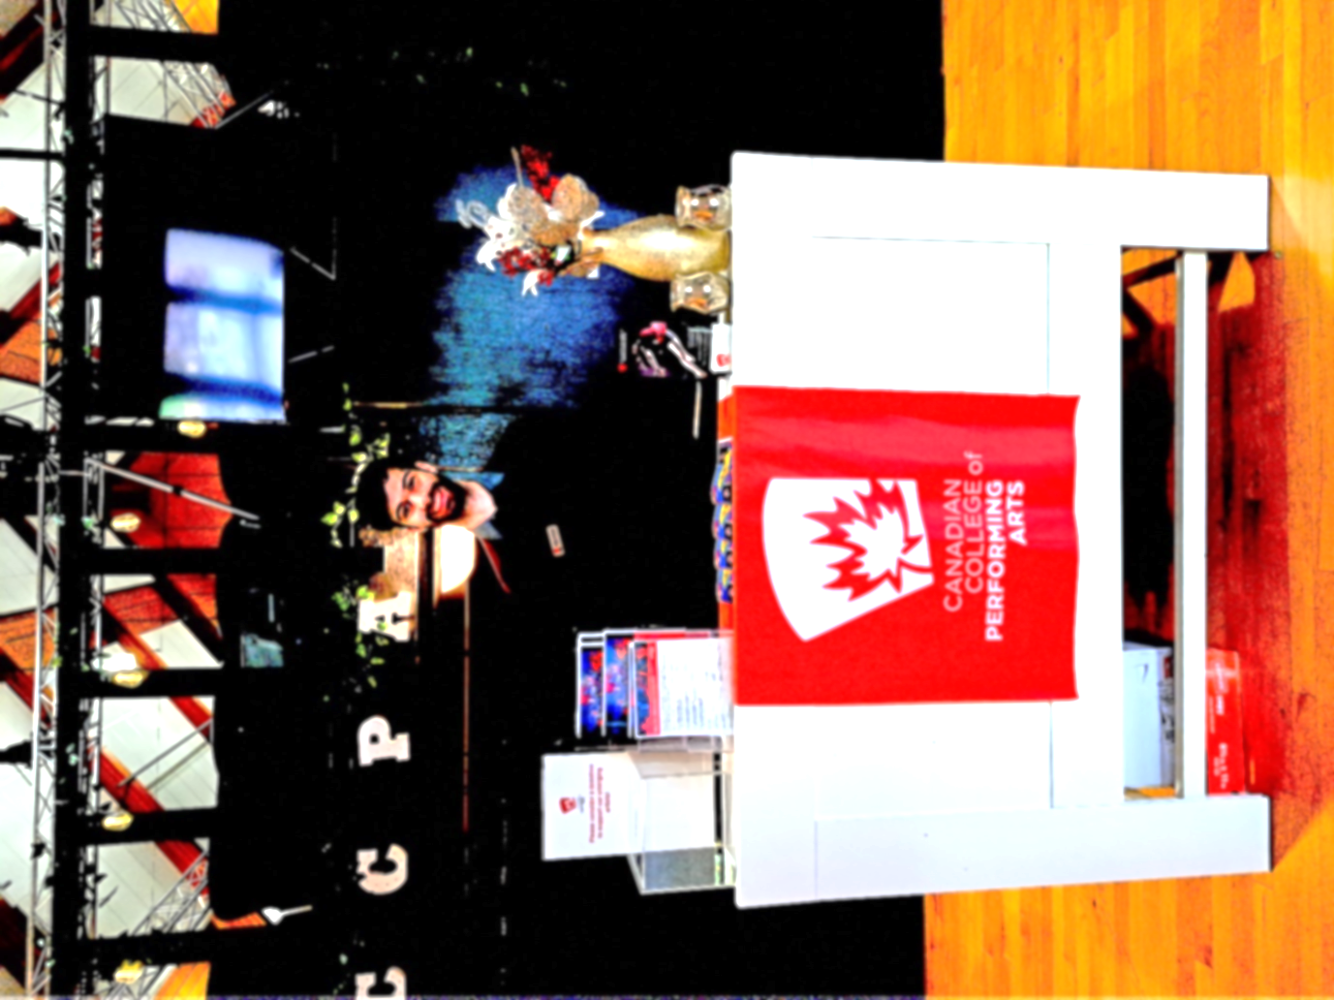

If you require a special accommodation, please contact us in advance at 250 595 9970 extension 104.

These are the doors into the Performance Hall.

You can pick up a program from a volunteer outside

the doors.

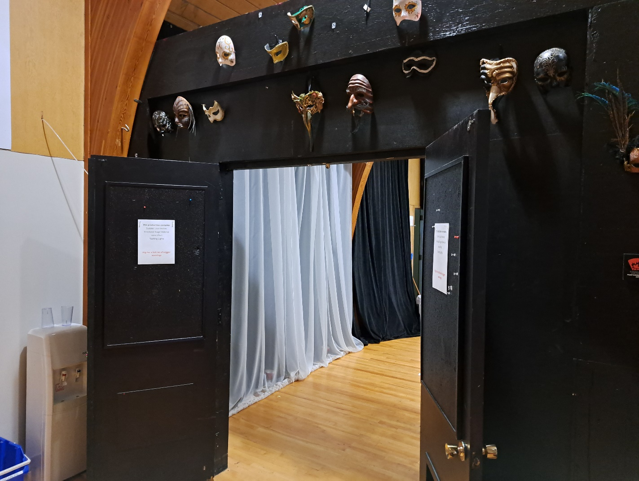

Ushers will be here to help you if you have a question.

Here is a picture of the shirt the ushers will be wearing. There may also be volunteers wearing nametags.

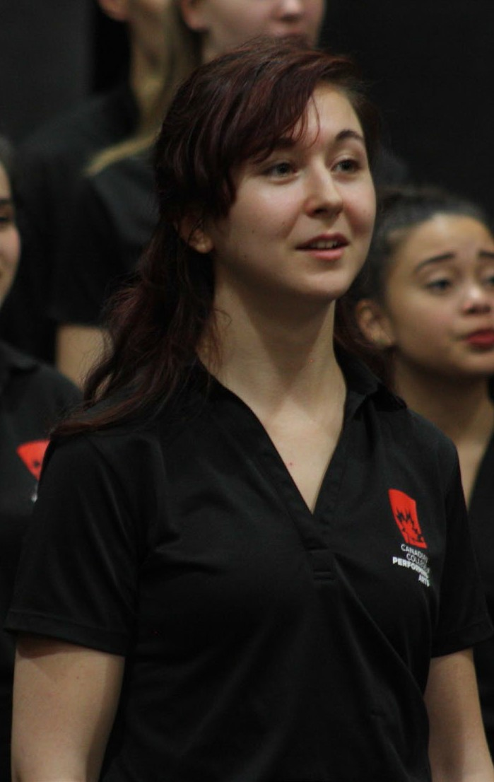

This set of doors leads to the hallway where the washrooms are.

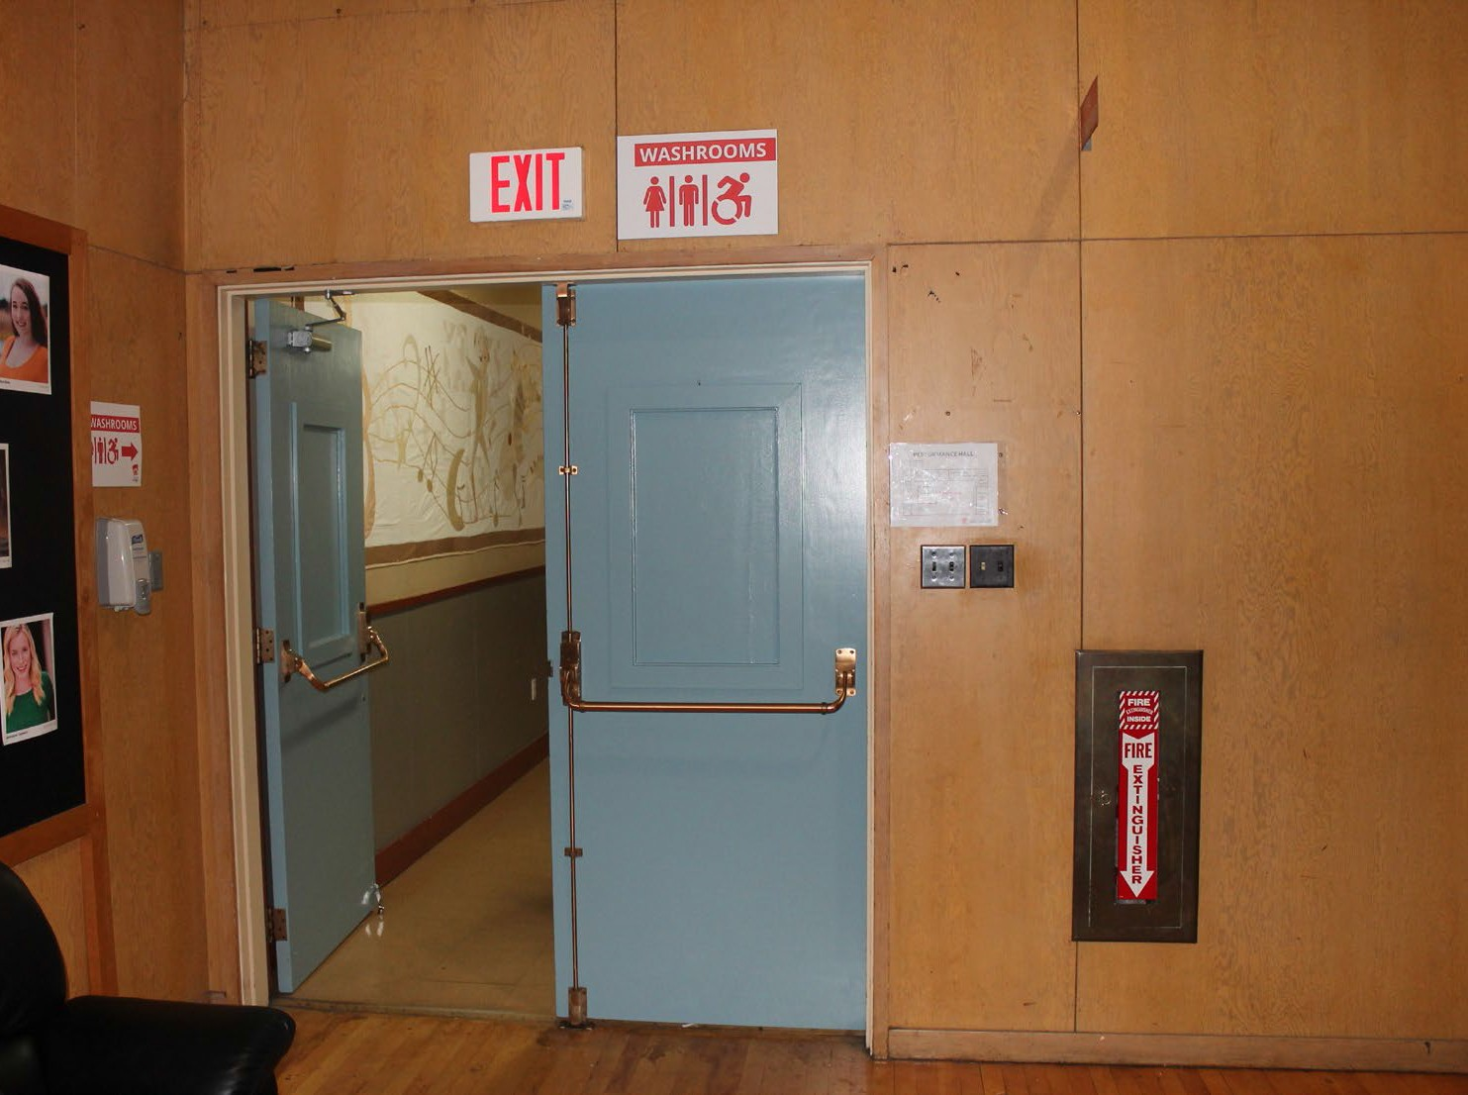 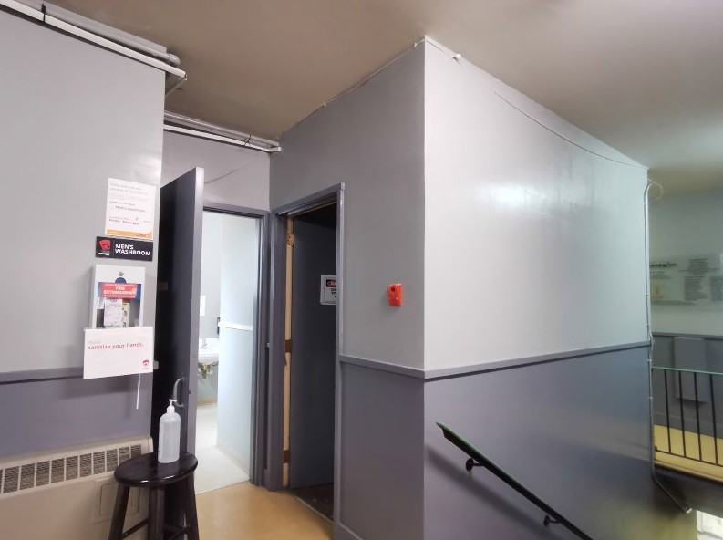

The single door at the end of the hallway is where the accessible washroom is.

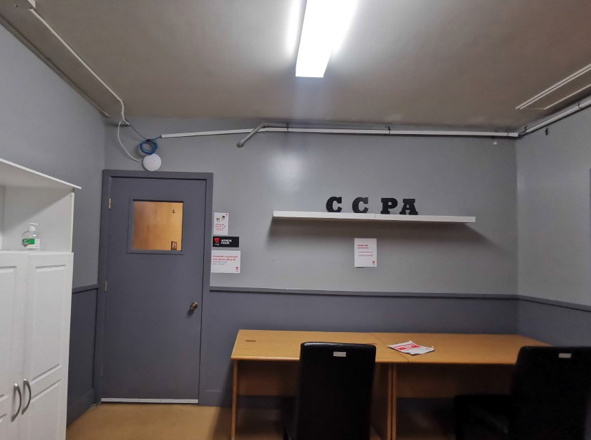 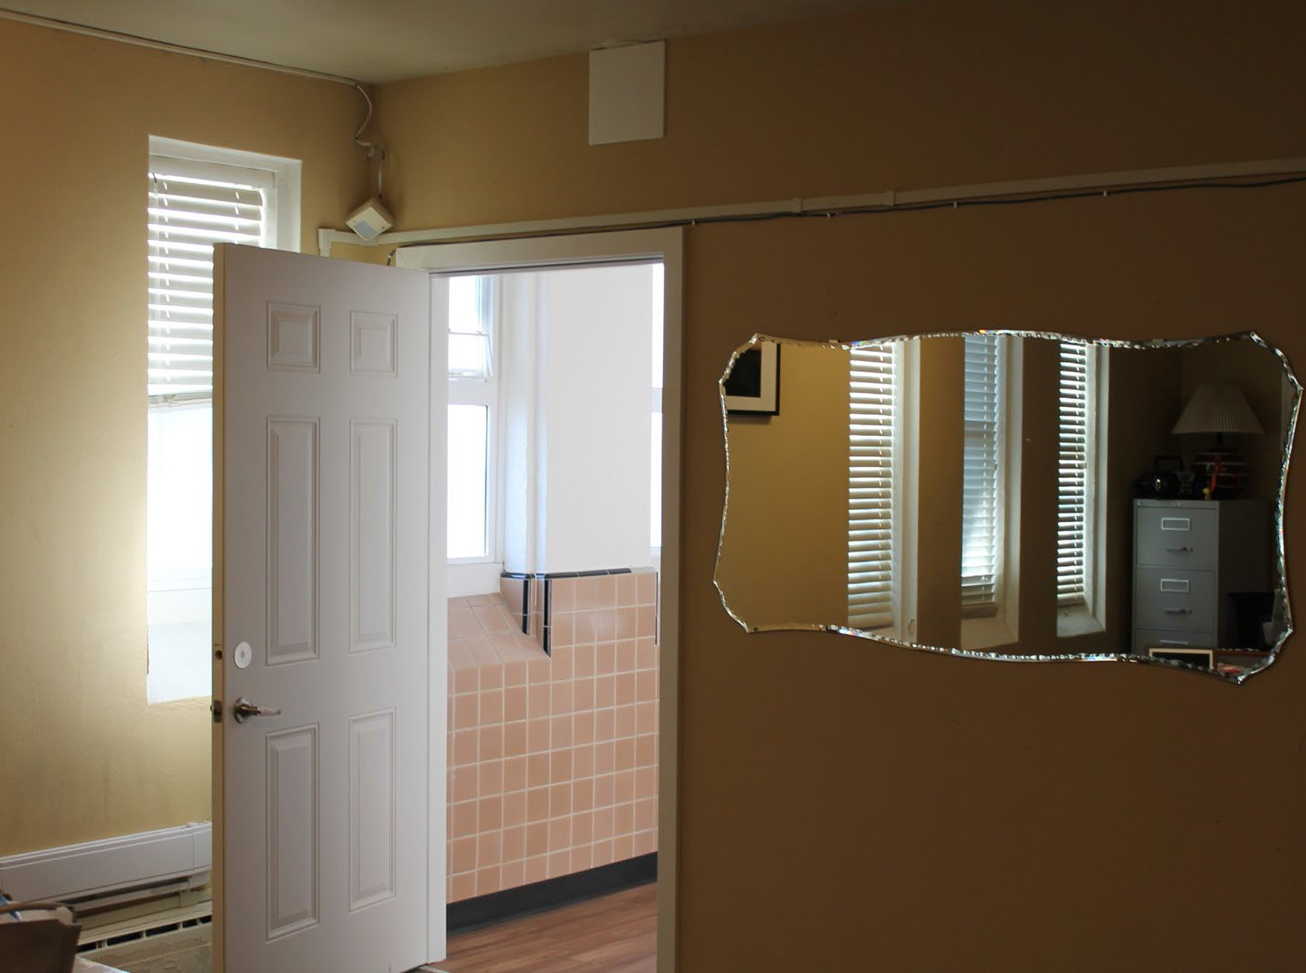

We have a quiet calm space available. You can leave the Performance Hall any time during the show to relax. It is near the entrance into the building.

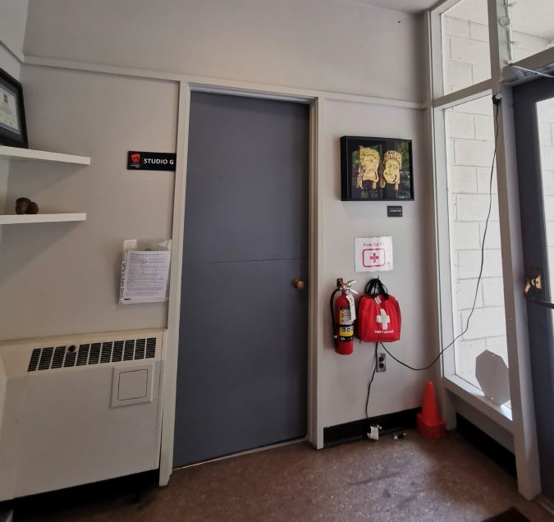 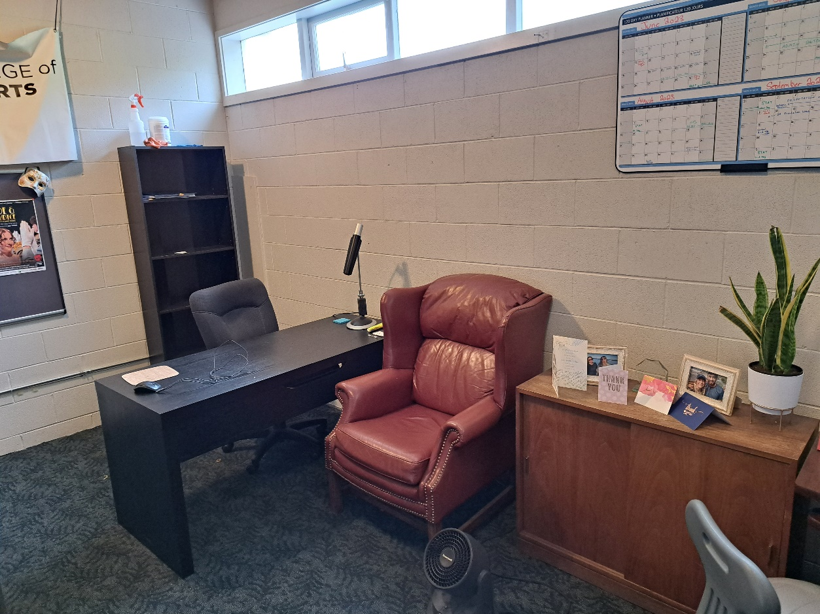

These are your seats in the Performance Hall. You can stand up and move around any time during the performance. The house lights will stay on so you can see.

